[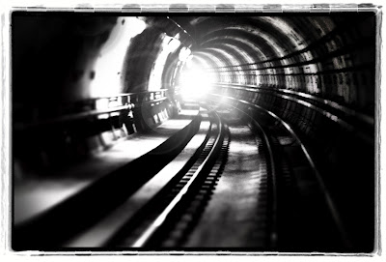](http://1.bp.blogspot.com/-xYsdKvni6v8/T6WCRw9M6mI/AAAAAAAAA78/x9zVdQF0sdU/s1600/Light-at-the-end-of-the-tunnel.jpg)

Life underground is full of darkness, except for a few occasional blue and red that flash past me as I pass; And a few stations, where people come and people go. Otherwise, life underground is a constant run on the track, along parallel electric cables stapled to the concrete walls, whom I dare not touch in fear of losing a limb and skin. It's quiet underground, devoid of the cycles of day and night. Even the compass is as bewildered as me, agitated, and furiously oscillating, fretting over its inability to find its pole star. There was a time when it'd find its pole star irrespective of time. Time, is all it is also counting on, to re-emerge on the surface. I empathize, and suddenly it constantly points at me. But, I am just a runner, somebody tell this to the compass. The mantle is where we all are lurking. Sometimes, a repairman comes along with his big lights and fine machines, and walks like he knows what he is doing. I am inclined to follow him out. 'But I am just a runner', this is what he tells. Just because he knows the way out doesn't mean he knows where it ends, he is just as lost as me, only that his scope is a little wider. Or so he tells. We're all runners, the compass, the cables, a repairman, and me, and we don't know where we are headed. We just run forward because...